Faculty of Engineering, Applied Sciences, and Technology
Lab Project

Course Code: BCS202 | Course Name: Introduction to Computing Science II
Date of Submission: 22nd November 2025 | Instructor(s): Dr. Mehak Khurana & Dr. Hamza

PHASE 1: Design the application

MENU-DRIVEN INVENTORY MANAGEMENT SYSTEM

- Product and PerishibleProduct Classes:
Represents a general product in the inventory.
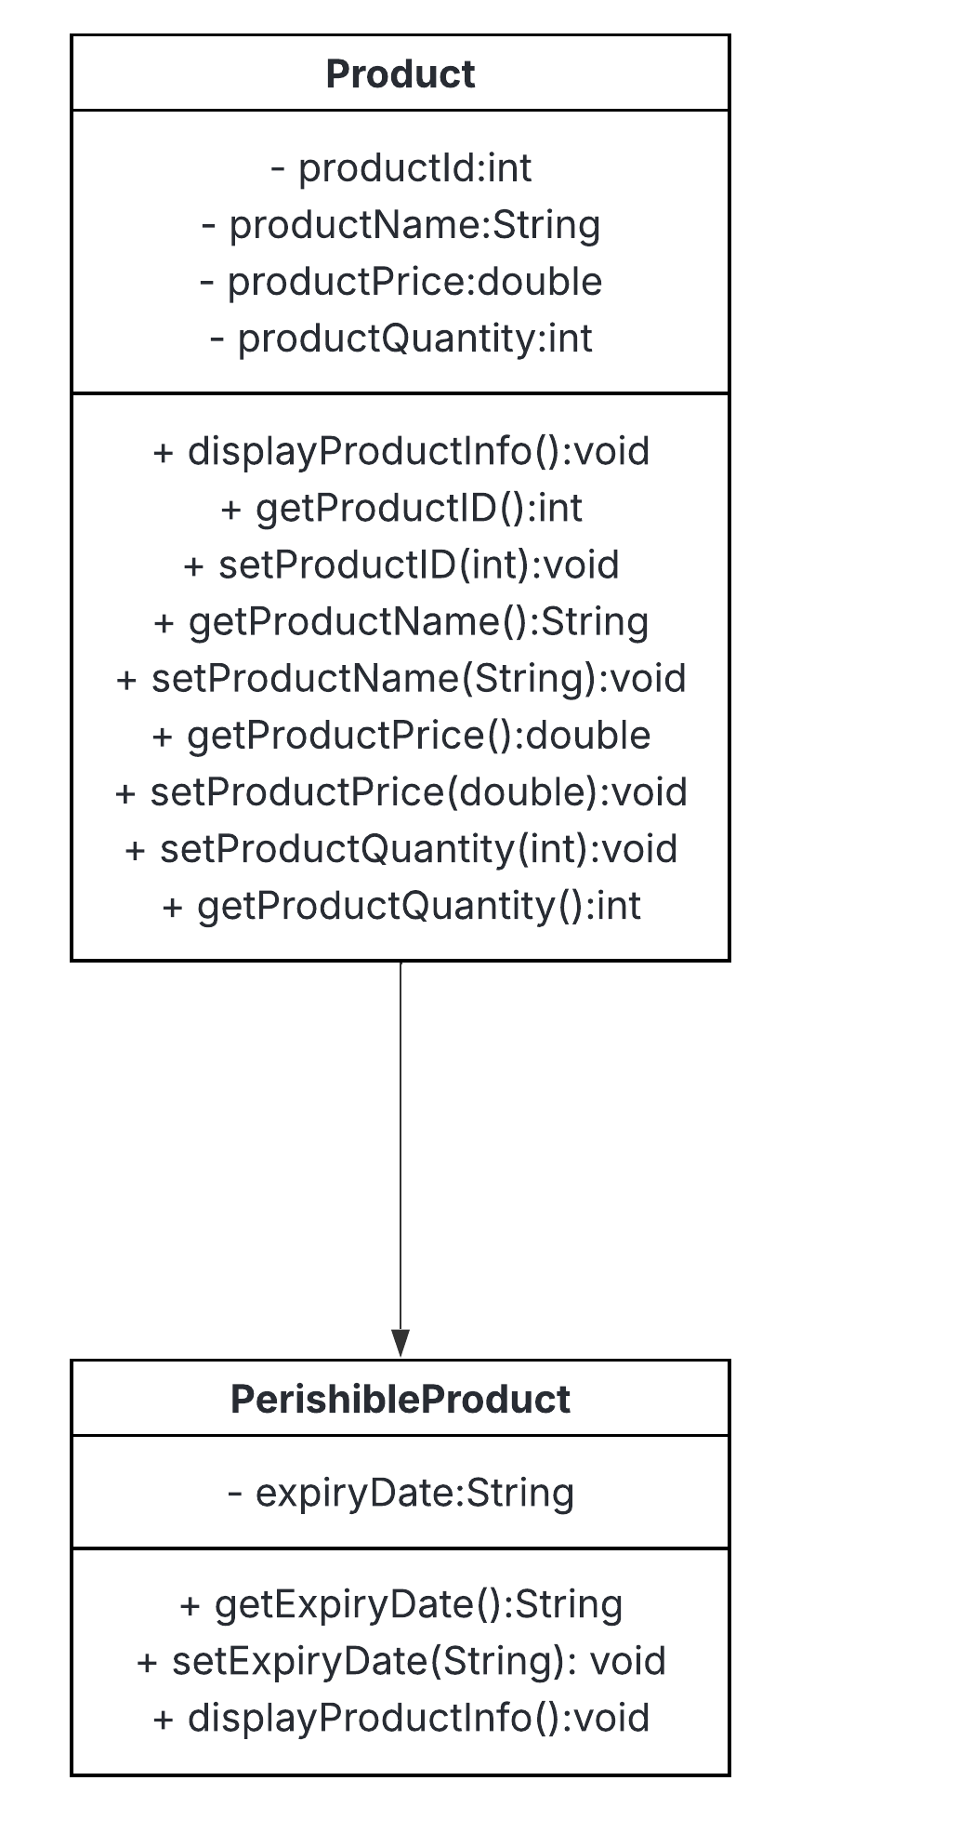
Each product has a unique ID, a name, a selling price, and the quantity available in the inventory. It has a parameterized and a default constructor, that creates a product.
It also extends the PerishibleProduct class, which inherits all attributes and methods of the Product class. It has its own additional attribute, expiryDate, which contains the expiration date of the product.
The method from the Product class, displayProductInfo(), gets overridden if it is expired.
- InventoryManager Class:
Manages all inventory operations with add, view, update, delete or search a product.
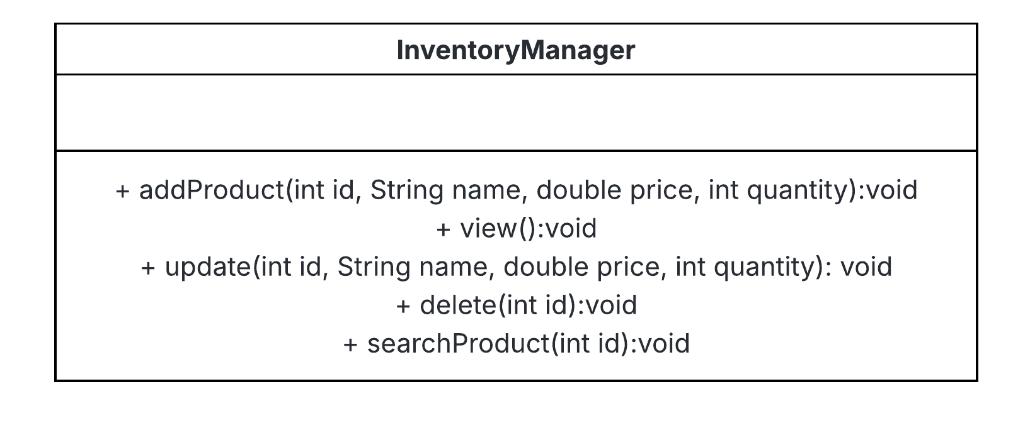
Has no attributes but has a fixed-size array for storing the products, and the methods for operating the product.
- Main Class
Handles the user interactions and the menu layout.
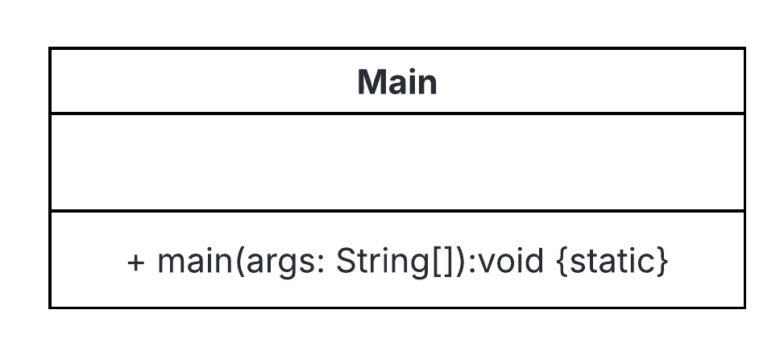

Console Outputs:
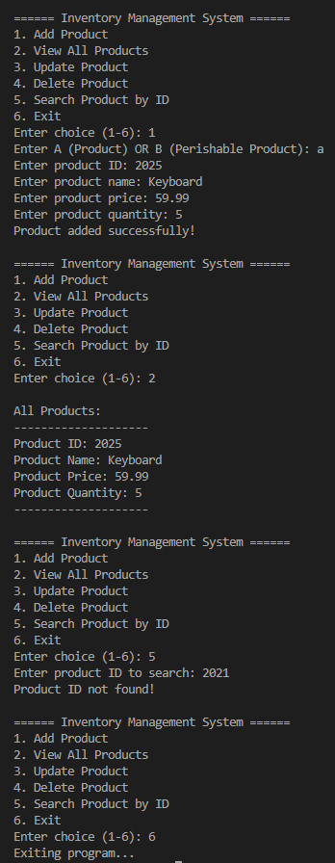
A product being added, all products being listed, searching a product, and exiting the program.

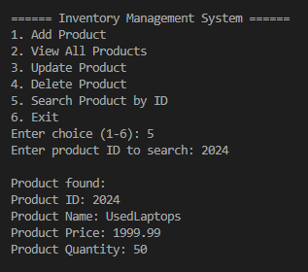
Searching and finding a product.

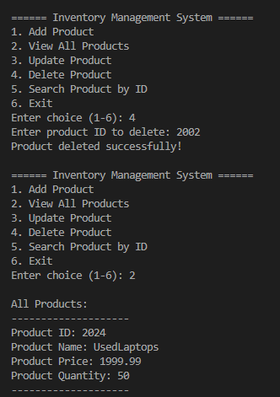
Deleting a product.

Updating a product

